Meridian FinServe
Threat Model
Workstream A × Workstream B — Combined Security Assessment

1. Threat Model Diagram
The diagram below presents the complete threat model for the Meridian FinServe environment, mapping threat actors and entry points through key threats to assets at risk and business impact.
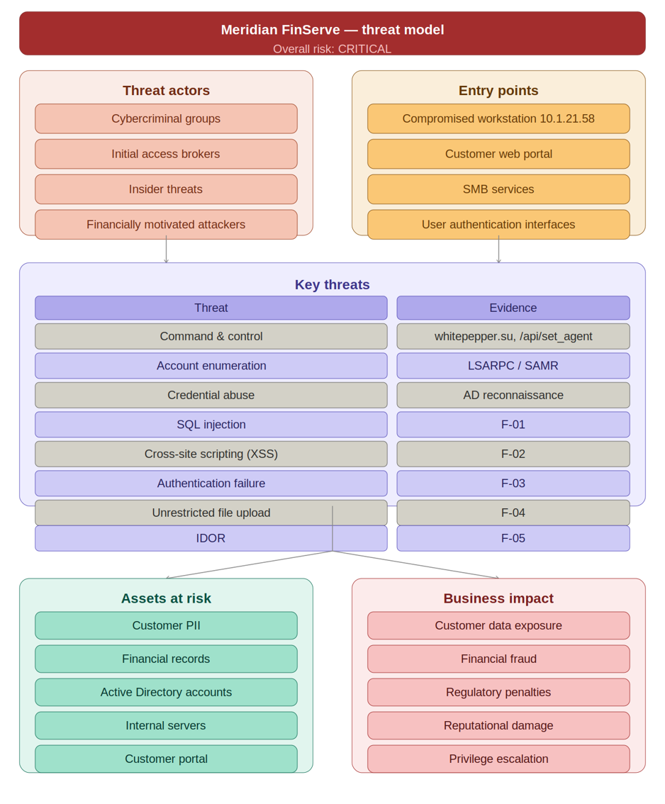

2. Assets
The following assets represent the critical information and infrastructure components within the Meridian FinServe environment that are exposed to threat actor activity.

Protected Assets
- Customer PII — personal and financial identity data held for customer accounts
- Financial Records — transaction history, account balances, payment data
- Active Directory Accounts — domain user accounts, privileged service accounts, group memberships
- Internal Servers — backend infrastructure including application, database, and file servers
- Customer Portal — the externally accessible web application serving customer self-service functions

3. Threat Actors
The following threat actor categories represent realistic adversaries with the motivation, capability, and opportunity to target the Meridian FinServe environment.

Identified Threat Actors
- Cybercriminal Groups — organised criminal entities seeking financial gain through data theft, fraud, or ransomware deployment
- Initial Access Brokers — specialised actors who establish and sell network access to downstream criminal groups
- Insider Threats — current or former employees, contractors, or partners with legitimate access who misuse privileges intentionally or inadvertently
- Financially Motivated Attackers — opportunistic individuals or groups targeting payment data, customer credentials, and account takeover for direct monetary gain

4. Entry Points
The entry points below represent the attack surfaces through which a threat actor could gain initial access to or escalate within the Meridian FinServe environment.

Identified Entry Points
- Compromised Workstation (10.1.21.58) — observed establishing C2 communications; primary confirmed point of initial compromise
- Customer Web Portal — externally accessible application containing multiple exploitable vulnerabilities (SQLi, XSS, Auth Failures, IDOR, File Upload)
- SMB Services — internal SMB accessible from compromised workstation; used for LSARPC and SAMR enumeration against 10.1.21.2
- User Authentication Interfaces — login endpoints susceptible to credential stuffing, brute force, and authentication bypass attacks

5. Key Threats
The table below maps each identified threat to its supporting evidence from Workstream A (Network Forensics) and Workstream B (Web Application Security Assessment).
Threat | Evidence
Command & Control | whitepepper.su, /api/set_agent
Account Enumeration | LSARPC / SAMR
Credential Abuse | AD Reconnaissance
SQL Injection | F-01
XSS | F-02
Authentication Failure | F-03
File Upload Abuse | F-04
IDOR | F-05

6. Business Impact
Successful exploitation of the identified threats could result in the following material business consequences for Meridian FinServe.

Potential Business Consequences
- Customer Data Exposure — unauthorised disclosure of customer PII and financial records, triggering notification obligations under applicable data protection law
- Financial Fraud — account takeover and transaction manipulation resulting in direct monetary loss to customers and the organisation
- Regulatory Penalties — breach of financial services and data protection regulations may result in significant fines, enforcement action, and mandatory remediation
- Reputational Damage — loss of customer trust, adverse press coverage, and long-term impact on customer acquisition and retention
- Privilege Escalation — attacker progression from standard user access to administrative or system-level control, amplifying all other impacts

7. Overall Risk
The combined assessment of threat actor capability, asset exposure, entry point accessibility, and vulnerability density yields the following overall risk rating.

Overall Risk Rating | ⚠ CRITICAL  The environment currently lacks sufficient controls to interrupt the attack chain at any single stage.
The environment currently lacks sufficient preventive and detective controls to interrupt the attack chain at any single stage. Immediate remediation action is required across endpoint security, network segmentation, and web application hardening to reduce the overall risk rating to an acceptable level.

